**Compare Two String**

This document will explain how to use compare text.

Please go through the following sample automation **Compare text. Zappy** file.

**Compare Text** actions will check whether both strings are equal or not.

**Step 1:** Right click on Zap icon and select Task Editor (or Double click on zap icon).

**Step 2:** Open the **“Compare text. Zappy”** file.

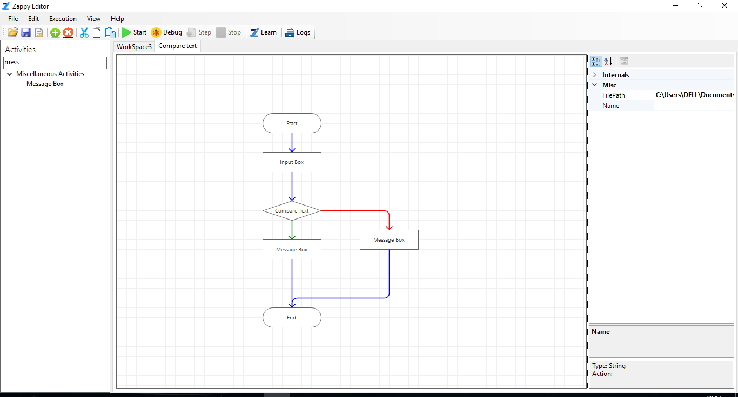

**Step 3:** To start the execution click on start icon  .

**Step 4:** Enter "Hello" message it's return **"welcome to Zappy"** if string is Exactly Match otherwise it will return **"string not match”** message and click on **OK** button.

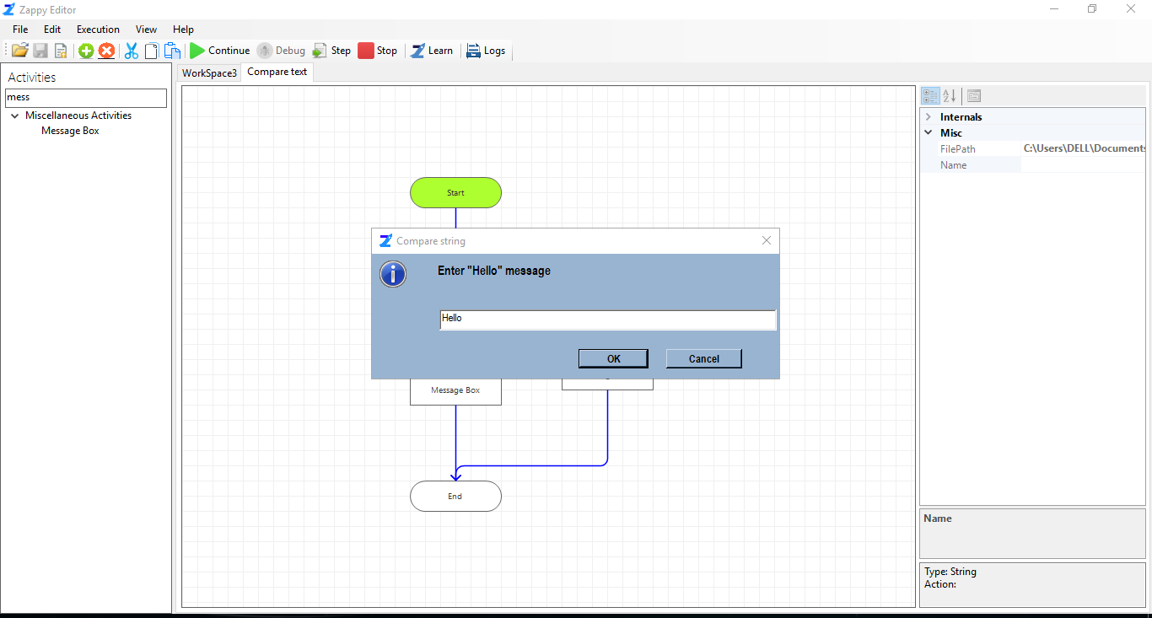

**Step 5:** The message will be displayed in the **Message Box,** then click on the **OK** button.

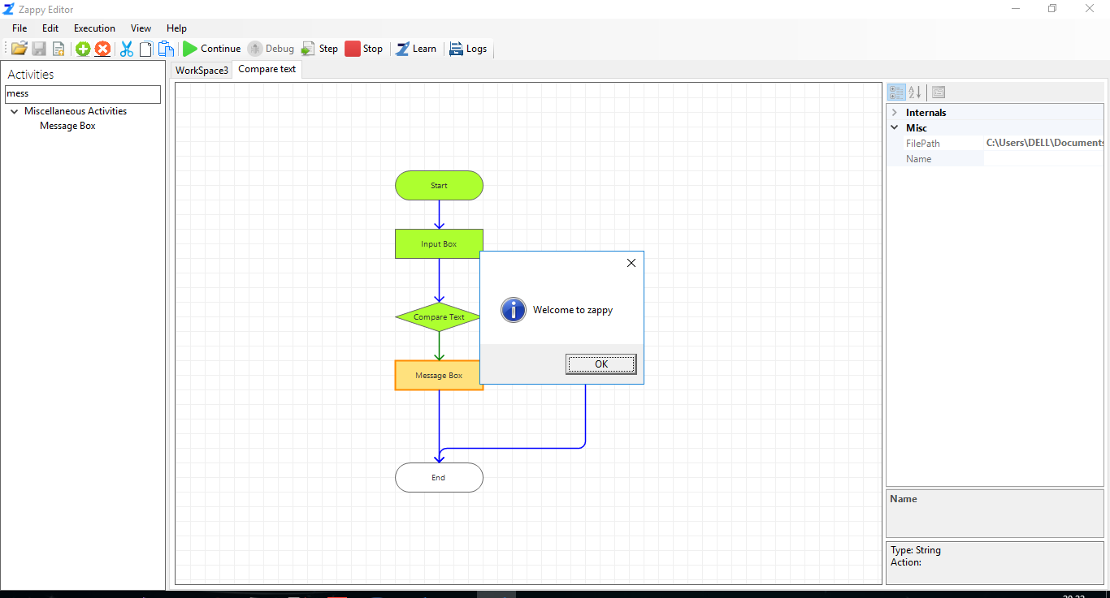

**In this way we can use Compare Text action for string comparison.**